1. Insert 5mm spacer on screw inside the top cover of box as shown below.

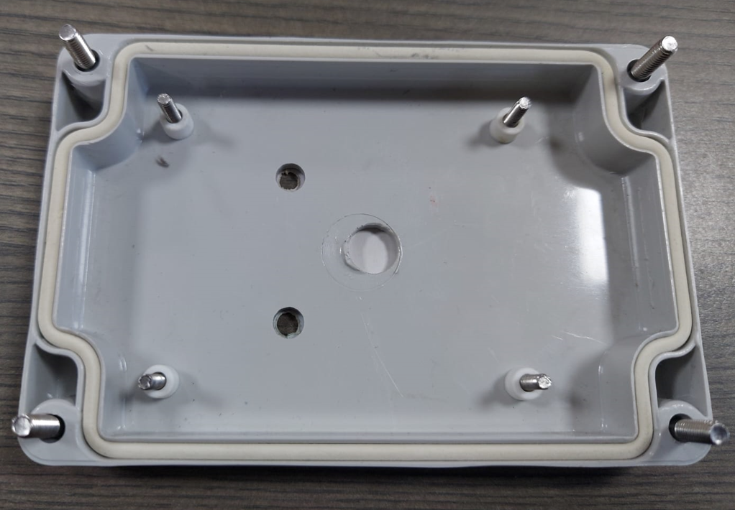

1. Mount assembled PCB correctly on spacers and insert fiber spacer on screw (3X15mm). After that insert 3mm nut and tight them as shown below.

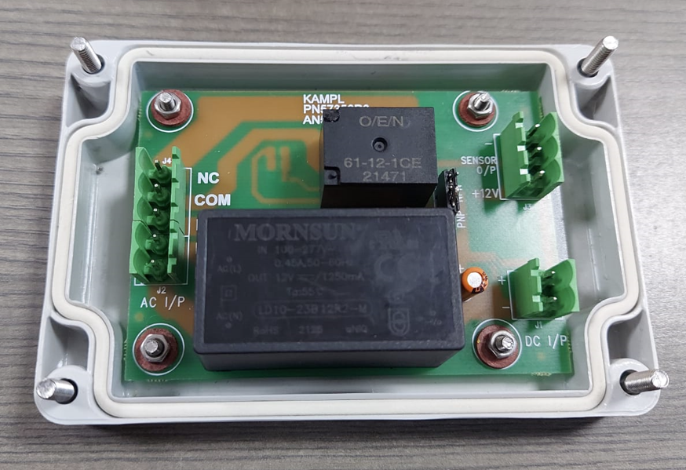

1. Connect cables on board as shown below. First take cables out from provided gland as per sensor side and supply, relay side, **Apply sealant DOWSIL 1080 RTV** around the gland lock nut entrance from the enclosure inside.

Open both cables (5 core and 3 core) up to 100mm length then screw them as per wiring diagram.

Tie cable using cable tie, for both cable near to gland.

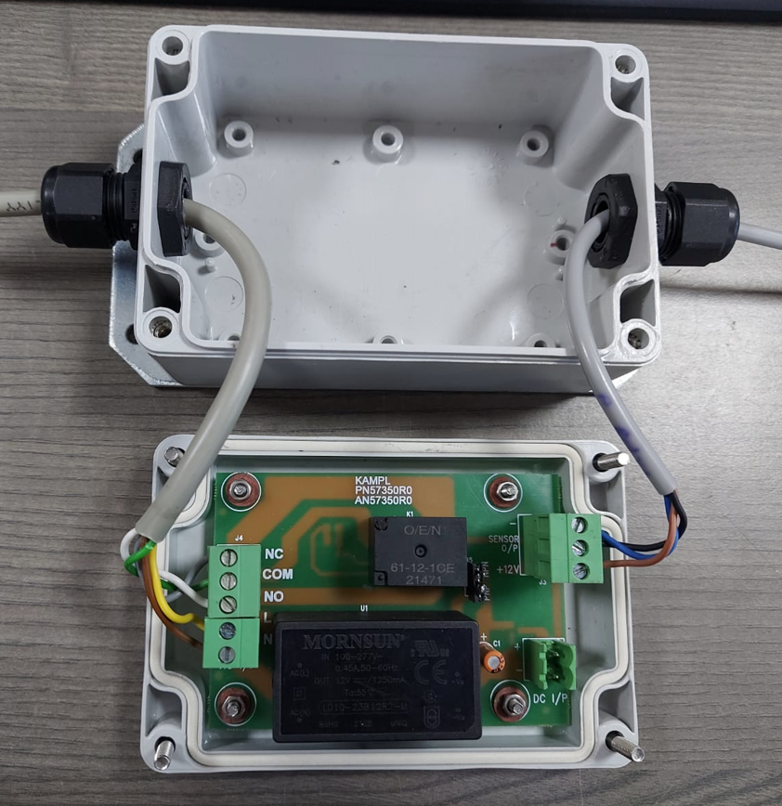

1. Assemble top cover (Facial) on the enclosure tight four screws on the corners and tighten the glands as shown in below image.

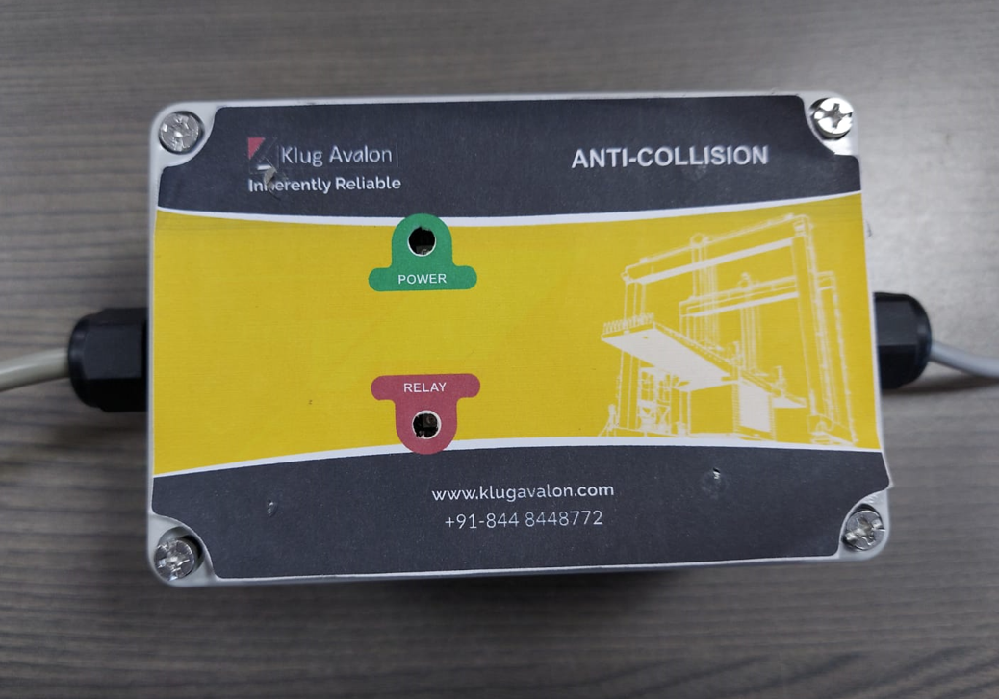

The final assembly of Anti-collision system is shown above. Apply sticker at the end of assembly.